Temasek Polytechnic

School of Informatics and IT

**Diploma in Information Technology (IT)**

Project Plan

**Project Particulars**

|  |  |
| --- | --- |
| **Tutor** | Qi Yutao |
| **Class** | P01 |
| **Project Title** | Delonix Regia Hotel Management System |

**Project Team’s Particulars**

|  |  |
| --- | --- |
| **Matric Number** | **Student Name** |
| **1604869F** | **Gauransh Mathur** |
| **1605712G** | **Wallace Toh** |
| **1601534I** | **Shynzi Tang** |
|  |  |

Revision History

|  |  |  |  |
| --- | --- | --- | --- |
| **Date** | **Version** | **Description** | **Author** |
| 12/10/2017 | 1.0 | First prototype added. It has basic UI and the network is working. The online payment system still has problems | Gauransh |
| 20/10/2017 | 1.3 | The online payment system has been fixed and the UI has been made more efficient | Gauransh |
| 2/11/2017 | 2.2 | After the major update, the network can now ping to all devices. | Gauransh |
| 25/11/2017 | 4 | The final prototype has been built and made efficient. The network is stable and no major bugs are being detected. | Gauransh |

Table of Contents

1. Introduction
   1. Objectives and scope of the project
   2. Assumptions and constraints
   3. Definitions and acronyms
2. Roles and responsibilities
3. Estimates and project schedule
   1. Work breakdown structure
   2. Project schedule
   3. Budget summary
4. Risk management plan

Project Plan

1 Introduction

1.1 Objectives and scope of the project

*[Describe the objectives of the project and the list of features that will be developed (the scope). Give brief descriptions of what deliverables the project is expected to deliver at the end of the project]*

The objective of this project is to create a hotel system to help Mr. And Mrs. Wang in their hotel. Each system that is being developed should help them improve their business. Like the room system should help the customers and the receptionist easily display rooms and their features like prices, accommodations which will improve the experience for the customer. At the end of the project the system should be able to store all information about the hotel, rooms, employees and also be able to complete digital transactions and have a digital log of inventory and rooms for efficient use by Mr. and Mrs. Wang.

The list of key features that are there for each module that is being developed are:

1) For the property management system, the key features are – Listing of all hotels or properties managed by the company with prices of maintenance and utilities. Listing of employees and their salary and purpose. Multi-currency conversions for payment.

2) For the front desk system, the key features are – Rate management to change rates per season. Event management for certain parts in the hotel.

3) For the room system, the key features are – room accommodations, guest list, vacancy and cleaning hours.

4) For the online payment system, the key features are – credit and debit card payment system. Minibar or room service auto billing, online booking payment.

1.2 Assumptions and constraints

*[Any assumptions underlying the project are stated here, together with constraints such as the delivery date, hardware/software availability etc. that will affect project management]*

The first assumption that was made was that, there wasn't an online payment system, also another assumption is that they didn't have a room model setup to co-relate and that they used a book keeping system. The third assumption made was that everything for the rooms weren't tracked digitally like the minibar and room service that is in available or phone and WiFi charges. The last assumption is that they don't keep track of multi-currency for their hotel so the customers cannot use other currencies instead of SGD.

Constraints that will affect project management are, the hardware to connect all devices to the network may be expensive and require time to install. Another constraint is that the learning curve for Mr. and Mrs. Wang to understand how the system works so they can use it efficiently, making us spend time on making the UI much simpler. The last constraint is that they would require constant maintenance of the system because of the hardware that is there.

1.3 Definitions and acronyms

*[This ensures that the project plan is understood the same way by everyone]*

Users- Customers or the employees working in the hotel

Front-end – Coding the aesthetic and the button for the website

Back-end – Coding the database or connecting to the server for the website

2 Roles and responsibilities

*[Every team member is responsible for the analysis, design, implementation and testing of some features of the system. Describe who is responsible for which features. A particular feature can have more than one member responsible for it]*

Analysis of Book-Keeping system & acceptance of different currencies – Shynzi

Implementation & Testing of the different work on modules – Gauransh

Design and Budgeting of the different considerations eg, manpower - Wallace

3 Estimates and project schedule

3.1 Work breakdown structure

*[The work breakdown structure is a list of tasks that, if completed, will produce the final product. In general, any project can be broken down into 10-20 tasks. Organize the tasks based on phases and/or iterations. Break a large task into several sub-tasks if necessary. For each task, estimate the effort required in terms of days and decide who will be responsible for the completion of the task. Identify all major milestones and important release points]*

**Task No. Task Name Duration**

**1 Requirements and Scope**  1days

2 Plan and disseminate roles 1day

3 Managing/Monitoring 5days

4 **Module Development/Design**

5 Work on First Module 4days

6 Work on Second Module 4days

7 Work on Third Module 4days

8 Work on Fourth Module 4days

**9 Implementation**

10 Conception and Approval 1day

12 Module 1 Testing 2days

13 Module 2 Testing 2days

14 Module 3 Testing 2days

15 Module 4 Testing 2days

16 Maintainence

3.2 Project Schedule

*[Use Microsoft Project 2003 to draw a detailed schedule, showing target dates for completion of iterations and phases, release points, demos and other milestones. It should also show the dependencies between activities, the estimated time required to reach each milestone and the allocation of people to activities]*

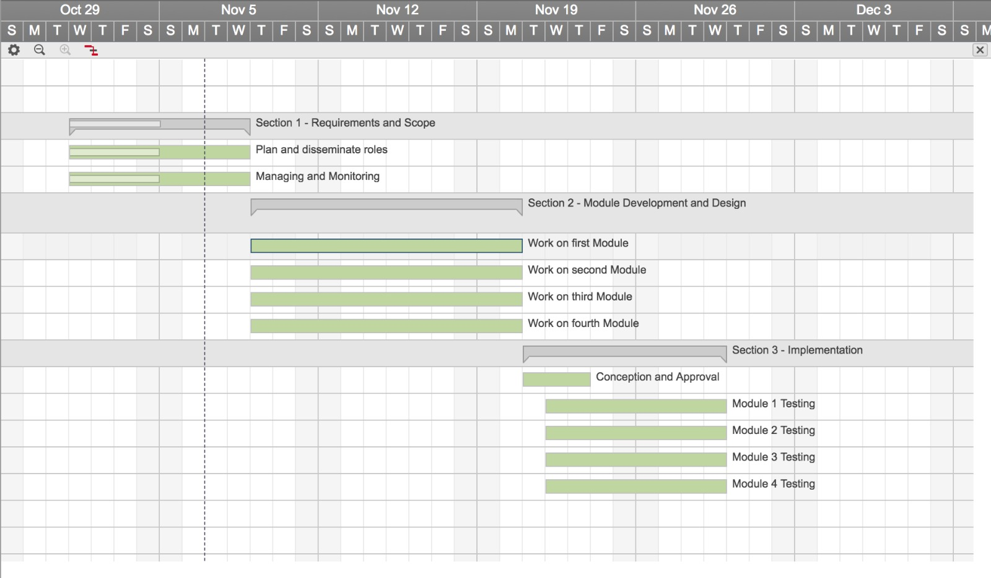

3.3 Budget Summary

*[Give a summary of the estimated budget required to complete the project. Compute 1) manpower costs – based on the monthly salary of a typical software engineer and the duration of the project; 2) hardware costs e.g. PCs/servers, printers, scanners etc; 3) software costs e.g. microsoft visual studio, rational functional tester, microsoft project, macromedia dreamweaver etc]*

|  |  |
| --- | --- |
| Resource | Cost |
| Manpower  The average monthly pay of a software engineer is $4156 a month. We will be looking for quality experienced software engineers to ensure our system is decent, if not top form. Therefore, we will be setting the pay at $4000 a month.  The duration of the project is estimated to be around 1 month as shown in the project schedule in part 3.2, therefore the final cost for manpower will be set at $4000. | **$4000** |
| Hardware  1 PC at the front desk for booking in customers, verifying their booking, and modifying data. PC must have enough processing power for such tasks.  Another laptop for technical stuff, such as programming and reprogramming of the system. Can also be used as a backup for the front desk when there is a high traffic of customers.  Through thorough research, the Acer Aspire XC-780 Desktop and the Asus X456UQ Laptop fits the criteria. The prices listed on the right are respective to the hardware listed.  1 printer, scanner at front desk for printing forms or scanning document.  The Canon PIXMA MG2570S has both printing and scanning capabilities and is thus selected. | (Prices listed here are respective to the order of which the hardware is listed on the left.)  $898 +  $800 +  $59 =  **$1757** |
| Software  Photoshop CS6, for the designing of UI for the system. | **$699** |

Total estimated budget: $6456

4 Risk Management Plan

*[Describe possible project risks, the likelihood of these risks arising and the risk reduction strategies that are proposed]*

|  |  |  |  |  |
| --- | --- | --- | --- | --- |
| Type of Risk | Severity of Impact | Likelihood of Occurrence | Risk Exposure | Risk Management |
| Software Engineer Resign | High | Medium | 6/9 | Form a contract with the engineer stating that he has to complete the project. If he chooses not to finish it, he will be made to pay for damages to the business. |
| Customer not used to new system | Low | High | 3/9 | Customer can choose to do business with the hotel the usual way. In person. |
| Sudden growth in requirements | Medium | Low | 2/9 | Request more funds to fill up requirements. |
| Falling behind schedule | Medium | Medium | 4/9 | Monitor progress closely. |

|  |  |
| --- | --- |
| Workload | Person |
| Introduction –1.1 to 1.3, Revision history | Gauransh |
| 3.3. Budget Summary,  4. Risk Management Plan | Wallace |
| 3.1. Work Breakdown Structure,  3.2. Project Schedule | Shynzi |
| 2. Roles and Responsibilities | Bryan |